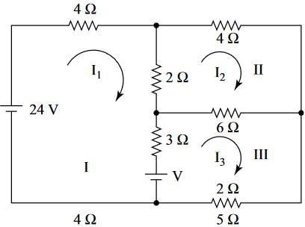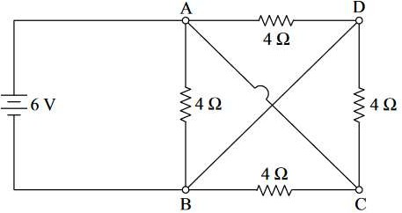Amrita Vishwa Vidyapeetham Amrita School of Computing, Chennai

Computer Science and Engineering-Cyber Security **20CYS102 – Principle of Engineering ASSIGNMENT 1**

Submission Date : 03-01-2023

|  |  |
| --- | --- |
| **CO** | **Course Outcomes** |
| CO1 | Ability to understand the engineering concepts and basic electric and magnetic circuits |
| CO2 | Ability to analyse DC and AC circuits. |
| CO3 | Ability to understand the basic principles of PN junctions and transistors |
| CO4 | Ability to analyse basic transistor and op amp-based circuits. |

|  |  |  |  |  |
| --- | --- | --- | --- | --- |
|  | **Part A - Answer all the question** |  | | |
| **1** | Using Superposition theorem calculate the current I for the given circuit |  | [BTL3] | [CO2] |
| **2** | A network with three meshes has been shown in Figure Applying Maxwell’s mesh current method determine the value of the unknown voltage, V for which the mesh current, I1 will be zero. |  | [BTL3] | [CO2] |
| **3** | Calculate the current supplied by the battery in the network shown in  Figure |  | [BTL3] | [CO2] |
| **4.** | Describe the working principle of PN junction diode under open circuit condition, forward bias and reverse bias condition with suitable diagrams. |  | [BTL3] | [CO3] |